Name:Charan kumar V
Reg no:192412365

Ex.No.7: Analog Beamforming Analysis Using MATLAB

Objective 1:
To analyze the beamforming gain achieved by varying the number of antenna elements in an analog beamforming system using MATLAB.

Program (Matlab Code)
clc;
clear;
close all;
antennas = [2 4 8 16 32]; % Number of Antenna Elements
gain = 10*log10(antennas); % Beamforming Gain (dB)
figure
bar(antennas, gain)
grid on

xlabel('Number of Antenna Elements')
ylabel('Beamforming Gain (dB)')
title('Beamforming Gain for Different Antenna Array Sizes')

Output:
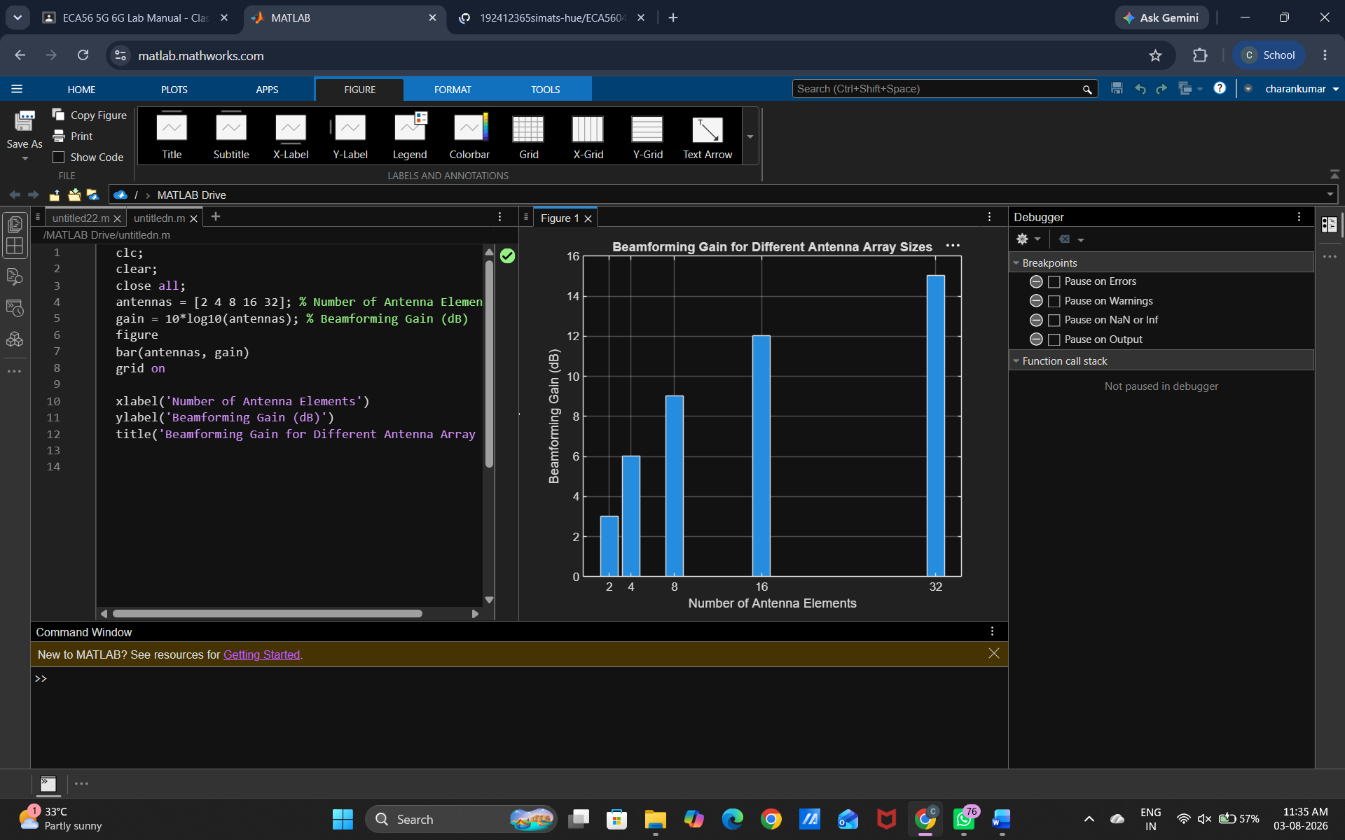

Objective 2:
To compare the beam width of an antenna array for different beamforming configurations using MATLAB.

Matlab Code
clc;
clear;
close all;
antennas = [2 4 8 16 32]; % Number of Antenna Elements
beamwidth = [90 45 22.5 11.25 5.625]; % Beam Width (degrees)
figure
plot(antennas, beamwidth,'o-','LineWidth',2)
grid on

xlabel('Number of Antenna Elements')
ylabel('Beam Width (Degrees)')
title('Beam Width for Different Antenna Array Sizes')

Output
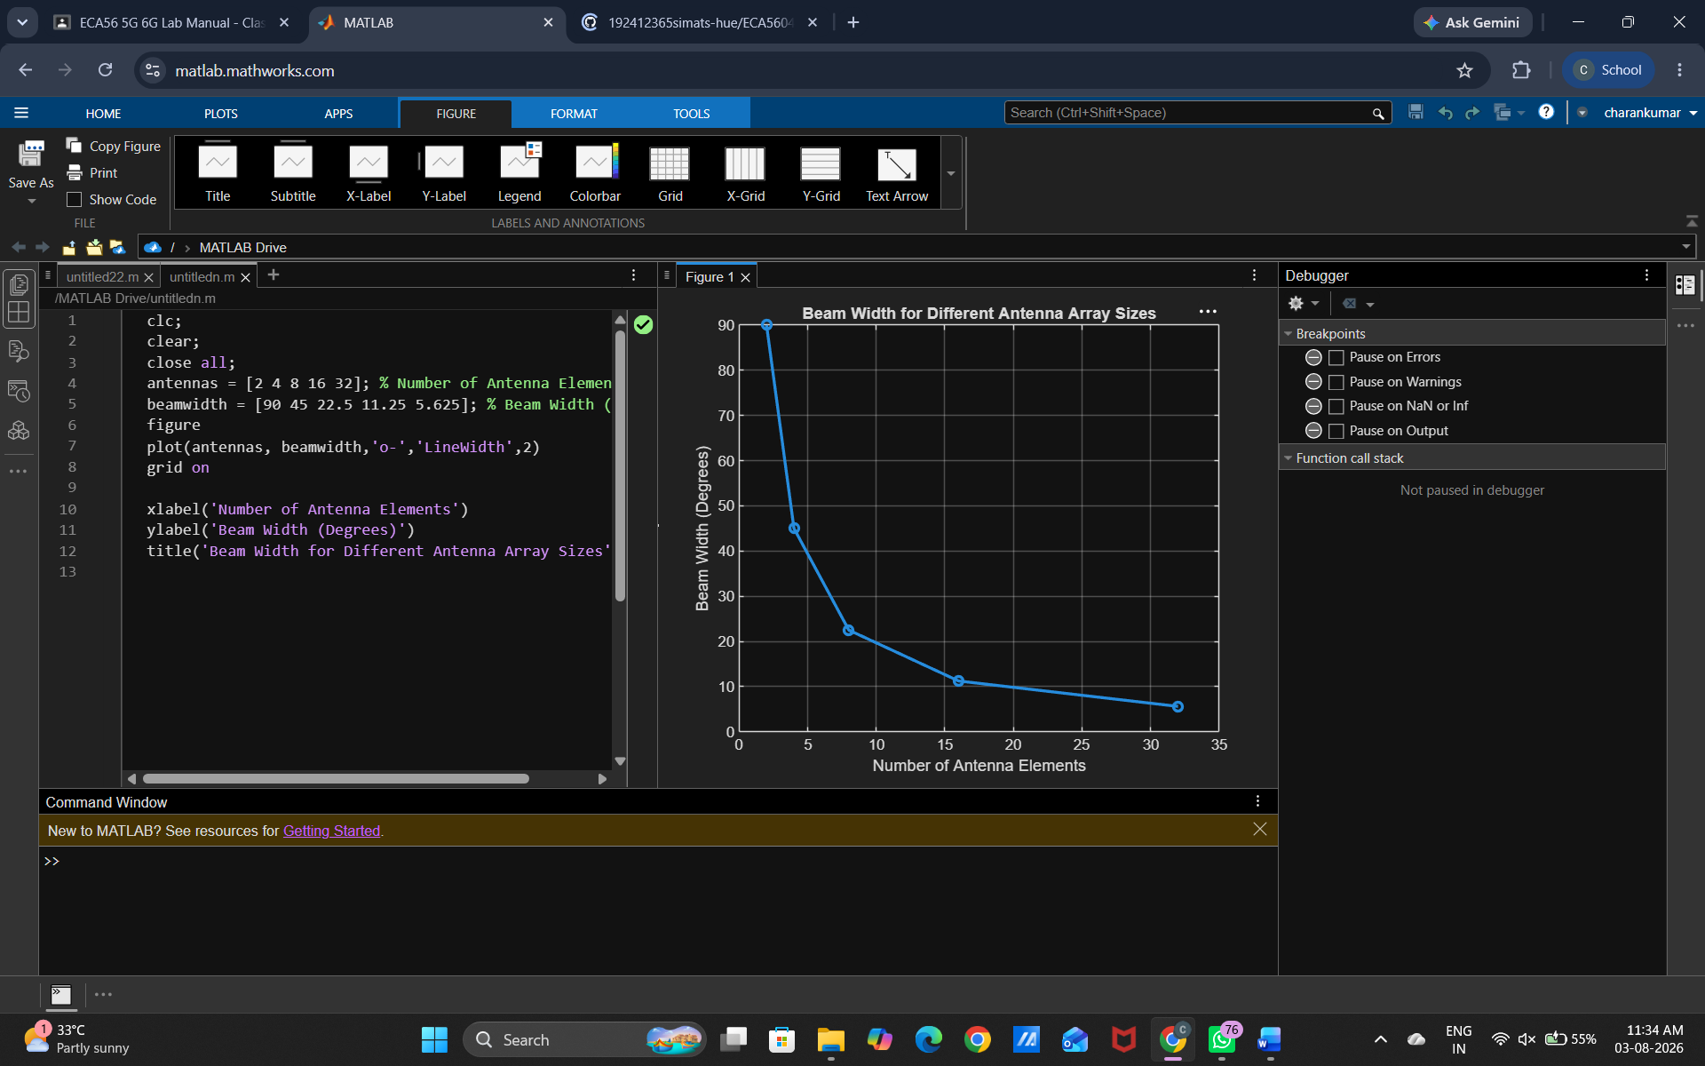

Objective 3:
To analyze the main lobe direction by steering the antenna array beam to different angles MATLAB.

Matlab Code
clc;
clear;
close all;
theta = [-60 -30 0 30 60]; % Main Lobe Direction (degrees)
gain = [1 1 1 1 1]; % Constant normalized gain
figure
polarplot(deg2rad(theta), gain, 'o', 'LineWidth', 2)
title('Main Lobe Direction in Analog Beamforming')

Output

